Examples, Types, and Shadows
Teens
Level 4 Lesson 23

- Introduction
Heb 8:5 Who serve unto the example and shadow of heavenly things, as Moses was admonished of God when he was about to make the tabernacle: for, See, saith he, that thou make all things according to the pattern shewed to thee in the mount.

Many Christians assume that the Old Testament tabernacle has nothing to do with our life in this day and age. But, when you study the tabernacle plan that God gave Moses, it is easy to see that the plan is a perfect type and shadow of what God has planned for the New Testament church!

- Lesson

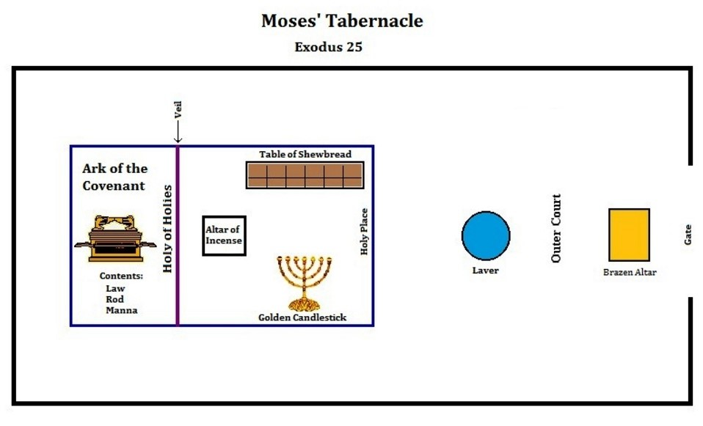

This is a simple diagram of the layout of the first tabernacle that Moses built from the plan that God gave to him. Gods plan was extremely specific. Nothing was made for no reason. There was a reason for everything. It is so exciting to realize that this plan was an example and pattern for us! This revelation makes it much more interesting to study the tabernacle plan of God. It was a perfect pattern of New Testament salvation.

The book of Hebrews ties in the Old Testament plan with our New Testament plan of salvation.

The first thing that the priests would do is go into the outer court. Here they would offer the sacrifice of a bullock or lamb on the Brazen Altar. They would shed the blood and then burn the animal with fire. Certain animals the priests would keep for their own meat. There were many rituals that they went through, and everything had to be perfect. Jesus died for us, as the animals died for them. Then when we come to God we must die to our old man in repentance.
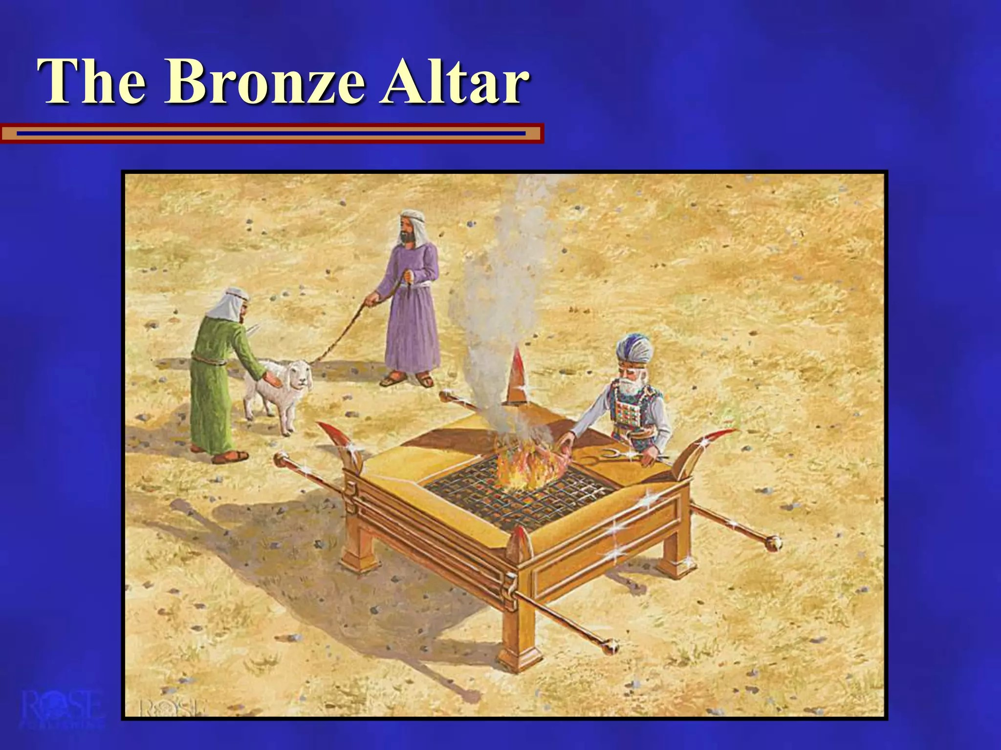

Then, they washed up at the Brazen Lavar. Jesus was baptized even though He was a sinless sacrifice. He did it as an example for us. So, we must be baptized in the name of Jesus to remove our sins from us (cleanse us).
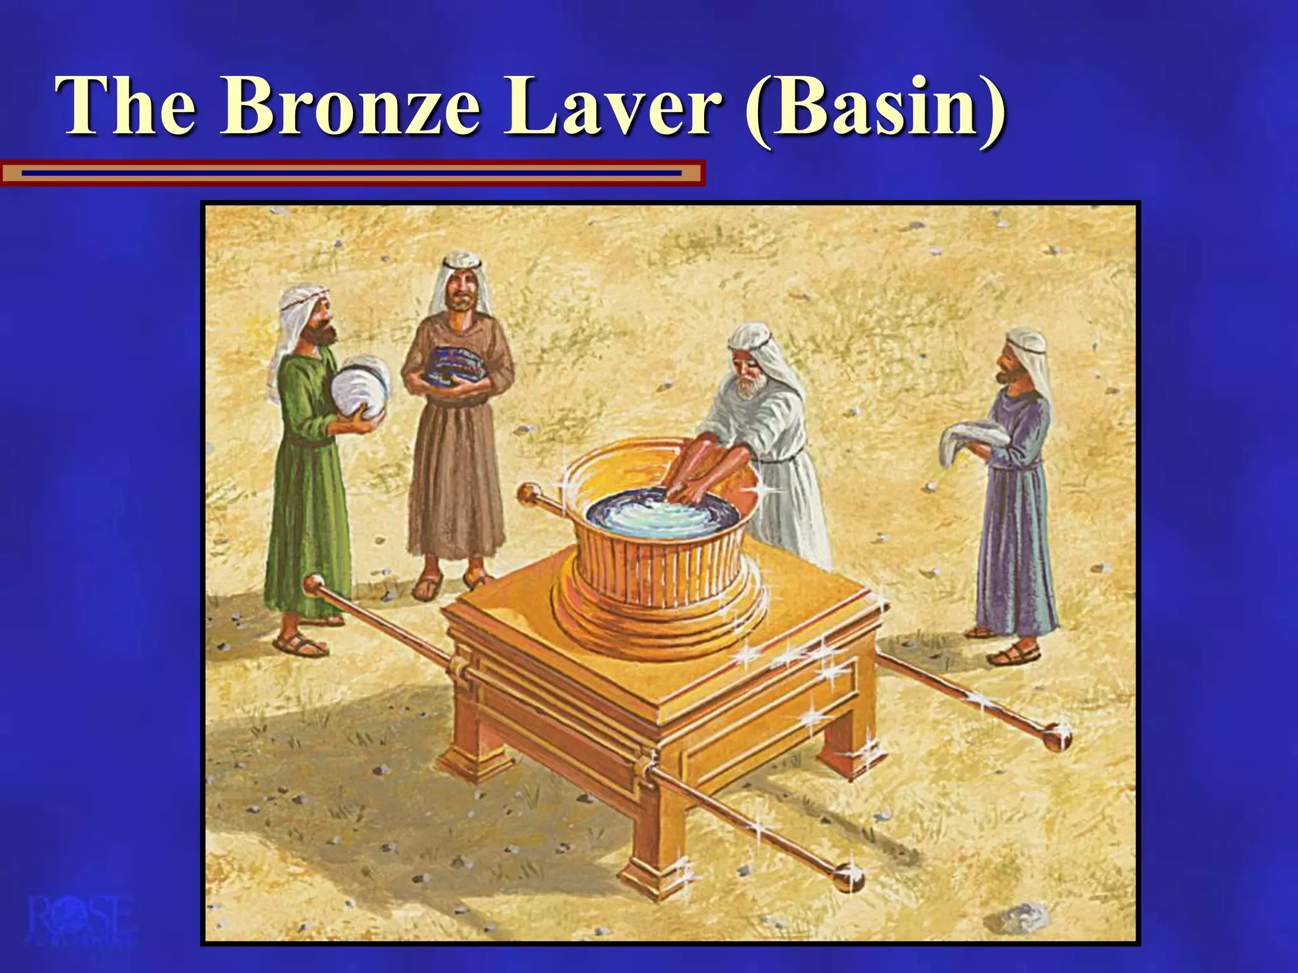

Onward into the holy place we will find the Golden Candlestick on the left. This was to give light to the priests ministering in the tabernacle. Jesus is the light of the world, and even so, we must let our lights shine before men.
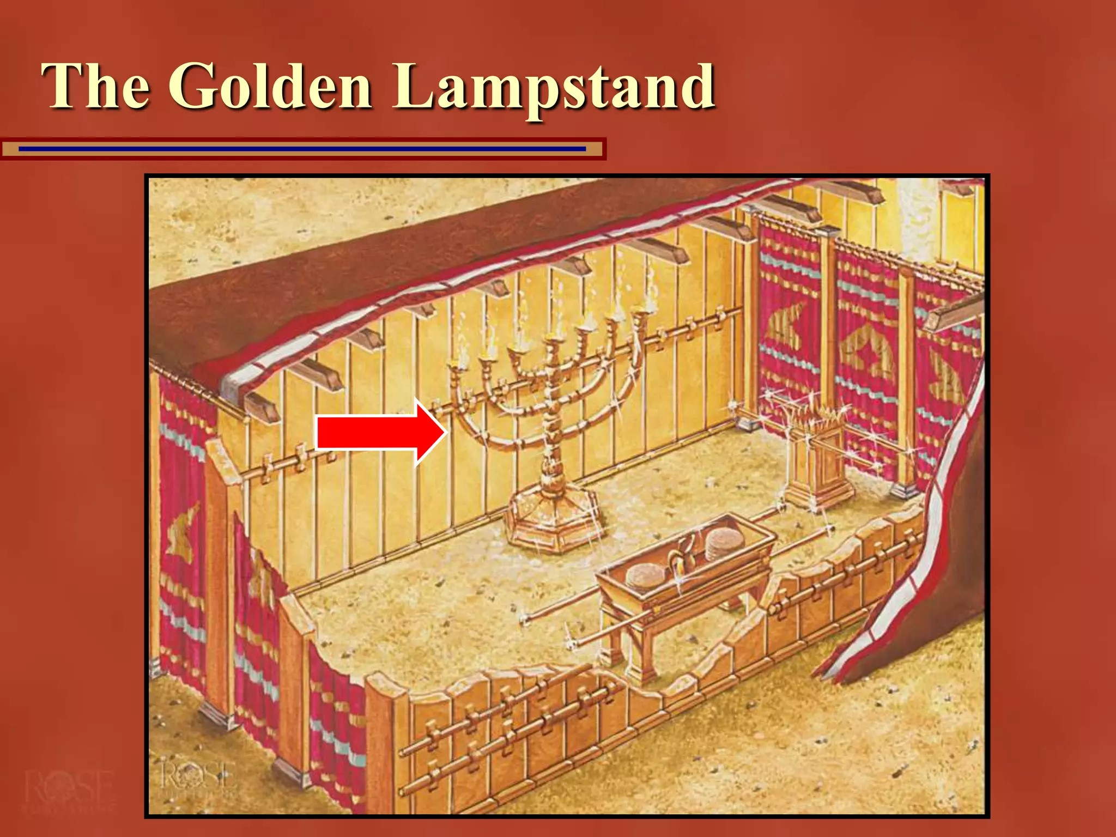

On the right stands the Table of Shewbread. The priests ate this unleavened bread for nourishment. It had to be renewed daily. There was bitter Frankincense on the outside of the bread, but the inside was tasty. Jesus Christ is the Bread of Life that came down from heaven. Even so, we must eat of the Word of God daily. Sometimes it rubs our flesh wrong, but after we have eaten of the Word we are nourished and strengthened.
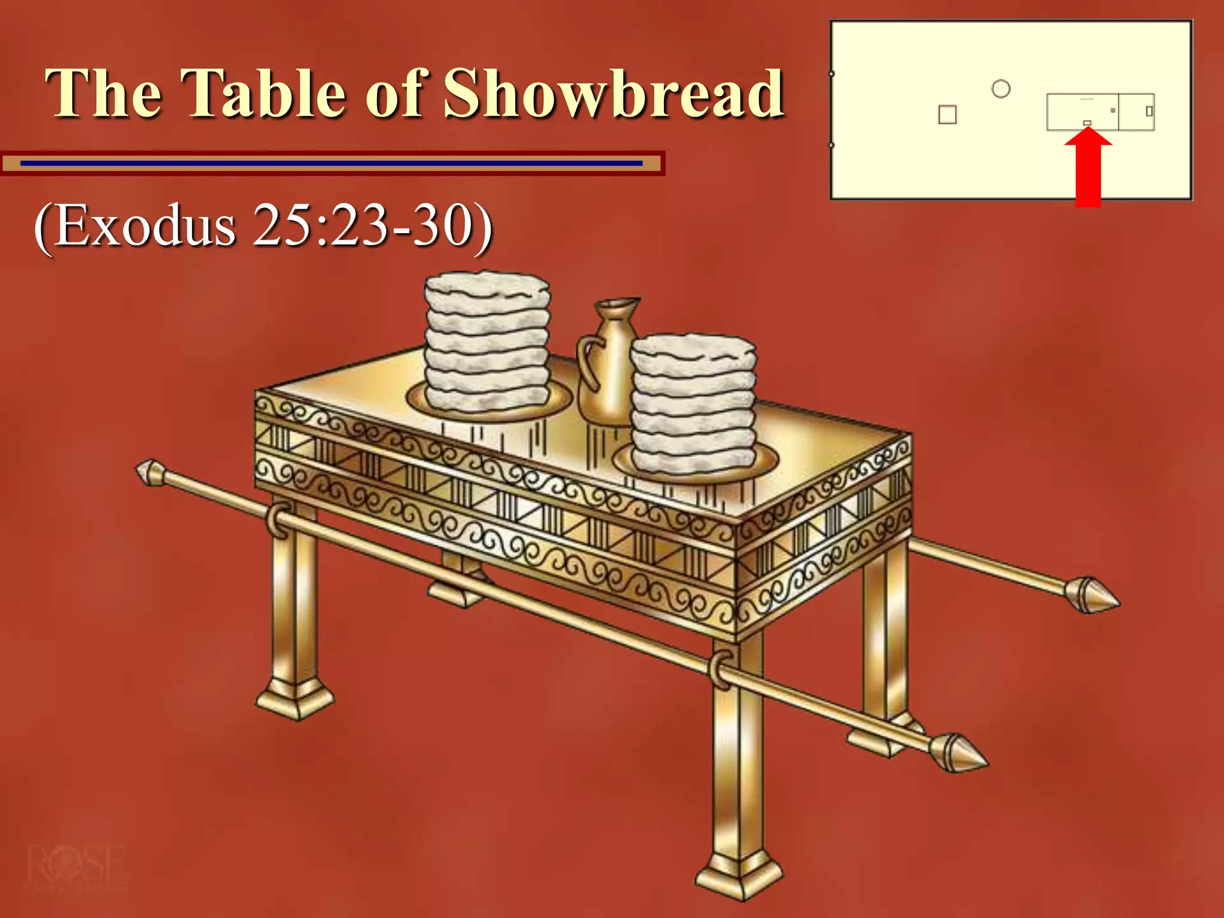

Then, before the veil of the Holiest of Holies stands the Altar of Incense. The priests came here and burned incense morning and evening every day. They brought the fire from the Brazen Altar. This piece of furniture in the Holy Place represents to us prayer. Jesus prayed in the garden to submit His flesh to the cross. We must bring the sacrifice of repentance to the altar of prayer for our prayers to have substance.
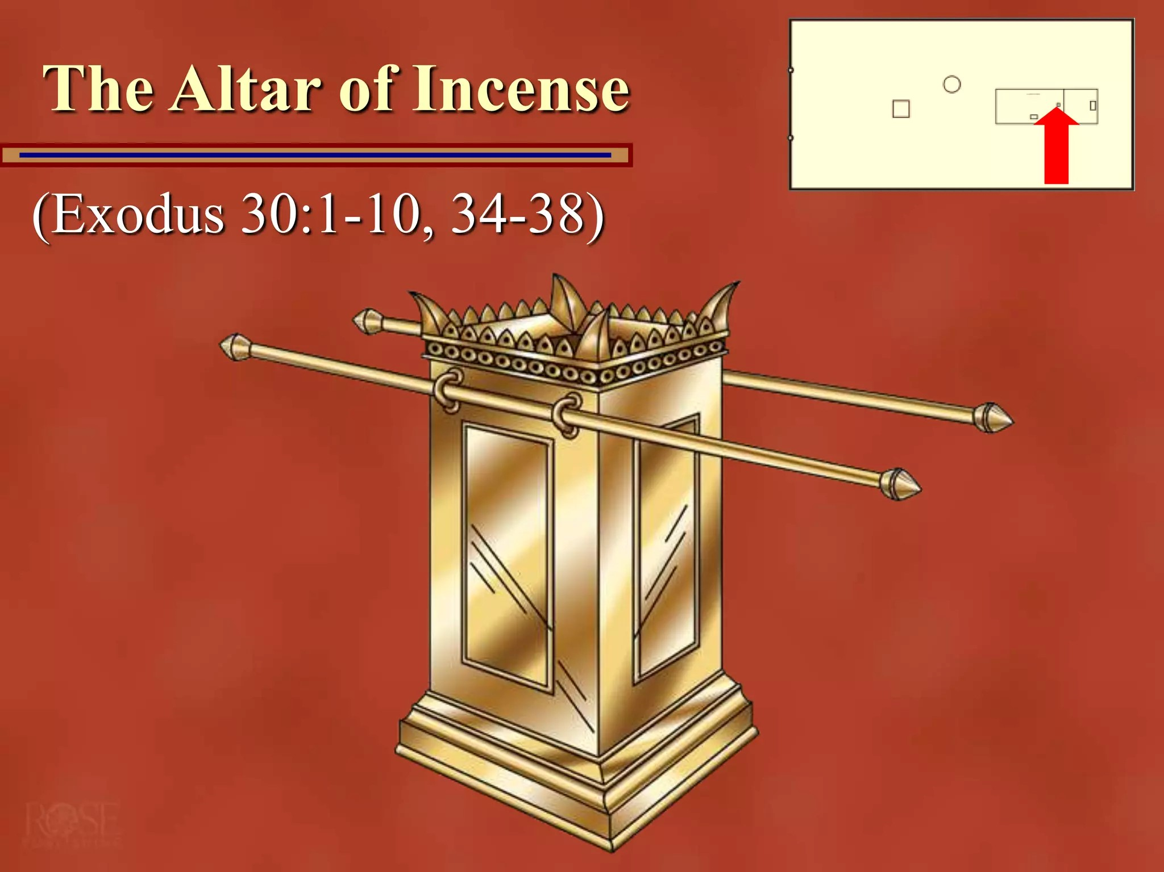

Then, only the high priest who was totally cleansed had a right to enter the Holiest of Holies. Jesus Christ was a sinless sacrifice for our sins. He broke through the veil into the place where God dwelt to release the Spirit of God to live in the repented man. He died; we repent. He was buried; we are baptized. And He rose again; we are filled with the Holy Ghost.

Heb 9:8 The Holy Ghost this signifying, that the way into the holiest of all was not yet made manifest, while as the first tabernacle was yet standing:

“The holiest of all” was the place where God would meet with the high priest once a year to apply the blood from the sacrifice for the atonement of their sins for the year. “Manifest” means to make clear. Back in the day of the Old Testament Tabernacle, they had no idea what it would mean in our day. They only saw their plan.

Heb 9:9 Which was a figure for the time then present, in which were offered both gifts and sacrifices, that could not make him that did the service perfect, as pertaining to the conscience;

Heb 9:10 Which stood only in meats and drinks, and divers washings, and carnal ordinances, imposed on them until the time of reformation.

But when Christ came on the scene, the veil was rent, and He became our sacrifice.

Heb 9:11 But Christ being come an high priest of good things to come, by a greater and more perfect tabernacle, not made with hands, that is to say, not of this building;

Heb 9:12 Neither by the blood of goats and calves, but by his own blood he entered
in once into the holy place, having obtained eternal redemption for us.

Heb 9:13 For if the blood of bulls and of goats, and the ashes of an heifer
sprinkling the unclean, sanctifieth to the purifying of the flesh:

Heb 9:14 How much more shall the blood of Christ, who through the eternal Spirit
offered himself without spot to God, purge your conscience from dead works to
serve the living God?
Heb 9:15 And for this cause he is the mediator of the new testament, that by means
of death, for the redemption of the transgressions that were under the first
testament, they which are called might receive the promise of eternal inheritance.

Christ’s dying is what changed the Testament. For, to have a testament, one must die.

Heb 9:16 For where a testament is, there must also of necessity be the death of the
testator.

Heb 9:17 For a testament is of force after men are dead: otherwise it is of no
strength at all while the testator liveth.

Heb 9:18 Whereupon neither the first testament was dedicated without blood.

Heb 9:19 For when Moses had spoken every precept to all the people according to
the law, he took the blood of calves and of goats, with water, and scarlet wool, and
hyssop, and sprinkled both the book, and all the people,

Heb 9:20 Saying, This is the blood of the testament which God hath enjoined unto
you.

Heb 9:21 Moreover he sprinkled with blood both the tabernacle, and all the
vessels of the ministry.

Heb 9:22 And almost all things are by the law purged with blood; and without
shedding of blood is no remission.

Heb 9:23 It was therefore necessary that the patterns of things in the heavens
should be purified with these; but the heavenly things themselves with better
sacrifices than these.

Heb 9:24 For Christ is not entered into the holy places made with hands, which
are the figures of the true; but into heaven itself, now to appear in the presence of
God for us:

Heb 9:25 Nor yet that he should offer himself often, as the high priest entereth into
the holy place every year with blood of others;

Heb 9:26 For then must he often have suffered since the foundation of the world:
but now once in the end of the world hath he appeared to put away sin by the
sacrifice of himself.

Heb 9:27 And as it is appointed unto men once to die, but after this the judgment:

Heb 9:28 So Christ was once offered to bear the sins of many; and unto them that
look for him shall he appear the second time without sin unto salvation.

They had no idea that the Tabernacle Plan of the Old Testament was a figure of the New Testament plan of Christ. But God’s plans are always perfect. There is nothing done by coincidence.

Heb 10:1 For the law having a shadow of good things to come, and not the very
image of the things, can never with those sacrifices which they offered year by year
continually make the comers thereunto perfect.

But we can be perfect in Christ when we obey the Plan! The Death, Burial, and resurrection.

- Activity

Encourage the students minds exploring what it would have been like to carry around the “Furniture” of the Tabernacle. The Tribe of Levi oversaw all things pertaining to the Tabernacle. Can you imagine what it would have been like to kill the sacrificial animal? It must have been very messy. Sometimes our Repentance seems very messy.
If you were a Levite, which job would you want?

